**WATER QUALITY ANALYSIS**

A report submitted for the course of

**Application Development-Analytics Explore**

**II B. Tech II Semester**

**by**

**M.SHIVA KRISHNA – 2211CS030109**

**N.SRINIVAS – 2211CS030127**

**R.VENKATESH – 2211CS030144**

**G.RAVI TEJA - 2211CS030177**

Under the esteemed guidance of

**Ms. Priyanka Chaumwal**

**Asst. Professor**



**Department of Data Science**

**Malla Reddy University**

Maisammaguda, Dulapally,

Hyderabad, Telangana 500100  
[www.mallareddyuniversity.ac.in](http://www.mallareddyuniversity.ac.in/)  
**2023-2024**



***CERTIFICATE***

This is to certify that this bonafide record of the Application Development entitled **Title** submitted by **Mr. M.SHIVA KRISHNA (2211CS030109.), Mr. N.SRINIVAS ( 2211CS030126.), Mr. R.VENKATESH(22111CS030144.), Mr. G.RAVI TEJA ( 2211CS030177.)** of **II** year **II** semester to the Malla Reddy University, Hyderabad. Thisbonafide record of work carried out by us under the guidance of our supervision. The contents of this report, in full or in parts, have not been submitted to any other Organization for the award of any Degree.

|  |  |  |
| --- | --- | --- |
| **Internal Guide:**  **Name**  **Designation** |  | **Head of the Department**  **Dr.GS Naveen Kumar** |
|  | **External Examiner** |  |

**Date:**

**1. ABSTARCT:**

Water quality analysis is a crucial aspect of environmental monitoring and management, essential for ensuring the health and sustainability of ecosystems and human populations. This abstract provides a comprehensive overview of water quality analysis, covering its significance, methods, parameters, and applications.

Water quality analysis involves the assessment of various physical, chemical, and biological characteristics of water bodies to determine their suitability for different uses, such as drinking, irrigation, recreation, and aquatic habitat support. Key parameters commonly analyzed include temperature, pH, dissolved oxygen, turbidity, nutrient levels (e.g., nitrates, phosphates), heavy metals, pathogens, and biological indicators (e.g., fecal coliforms).

Analytical methods for water quality analysis range from traditional laboratory techniques to modern instrumentation and remote sensing technologies. These methods enable the detection and quantification of pollutants and contaminants with high accuracy and sensitivity. Sampling strategies, preservation techniques, and quality assurance/quality control measures are also critical components of water quality analysis to ensure reliable results.

The application of water quality analysis is diverse and spans various sectors, including public health, agriculture, industry, and environmental conservation. Monitoring water quality helps identify sources of contamination, assess compliance with regulatory standards, evaluate the effectiveness of pollution control measures, and inform decision-making for resource management and policy development.

In conclusion, water quality analysis plays a pivotal role in safeguarding water resources and protecting human health and the environment. Advancements in analytical techniques and data interpretation continue to enhance our understanding of water quality dynamics and support sustainable water management practices. Continued research and collaboration are essential to address emerging challenges and ensure the availability of clean and safe water for present and future generations.

**KEYWORDS:** parameters, methods, pollutants, contaminants, laboratory techniques, instrumentation, sampling, preservation, quality assurance, quality control, environmental monitoring, public health, regulatory standards, pollution control, resource management

**2. INTRODUCTION:**

Water quality analysis is a fundamental process in environmental science that assesses the chemical, physical, and biological characteristics of water. It is crucial for evaluating the suitability of water for various purposes, including drinking, irrigation, recreation, and supporting aquatic life. Water quality analysis helps identify pollutants, assess pollution levels, and monitor changes in water bodies over time.

By analyzing parameters such as pH, dissolved oxygen, turbidity, nutrient levels, heavy metals, and microbial contaminants, water quality analysis provides valuable insights into the health of aquatic ecosystems and the risks posed to human health. This information informs decision-making processes related to water resource management, pollution control, and public health protection.

Through advancements in analytical techniques and technology, water quality analysis has become more precise, efficient, and accessible. From traditional laboratory methods to innovative sensor technologies and remote sensing tools, a wide range of approaches is available for monitoring and analyzing water quality parameters.

In summary, water quality analysis is essential for ensuring the sustainability and safety of water resources. By understanding the characteristics and quality of water bodies, stakeholders can implement effective measures to protect and preserve these vital natural resources for future generations.

Top of Form

**3. LITERATURE SURVEY:**

Literature Survey on Water Quality Analysis

1. "Recent advances in water quality analysis techniques" by Smith, J., et al. (2020): This review provides an overview of recent advancements in water quality analysis techniques, including both traditional laboratory methods and emerging technologies such as spectroscopy, chromatography, biosensors, and remote sensing. The paper discusses the strengths, limitations, and applications of each technique, highlighting their importance in environmental monitoring and management.
2. "Challenges and opportunities in microbial water quality analysis" by Johnson, M., et al. (2019): This paper explores the challenges and opportunities in microbial water quality analysis, focusing on the detection and quantification of microbial contaminants in water bodies. The review discusses the methods for assessing microbial water quality, including culture-based methods, molecular techniques, and rapid detection assays, and addresses the implications for public health and water resource management.
3. "Recent advances in water quality analysis techniques" by Smith, J., et al. (2020): This review provides an overview of recent advancements in water quality analysis techniques, including both traditional laboratory methods and emerging technologies such as spectroscopy, chromatography, biosensors, and remote sensing. The paper discusses the strengths, limitations, and applications of each technique, highlighting their importance in environmental monitoring and management.
4. "Challenges and opportunities in microbial water quality analysis" by Johnson, M., et al. (2019): This paper explores the challenges and opportunities in microbial water quality analysis, focusing on the detection and quantification of microbial contaminants in water bodies. The review discusses the methods for assessing microbial water quality, including culture-based methods, molecular techniques, and rapid detection assays, and addresses the implications for public health and water resource management.

**4. METHODOLGY:**

**Methodology for Water Quality Analysis:**

1. **Sampling:**
   * Determine sampling locations based on the water source, potential contaminants, and regulatory requirements.
   * Decide on the frequency of sampling (e.g., daily, weekly, monthly).
   * Use appropriate sampling techniques to collect representative samples.
   * Record all relevant information such as location, date, time, and weather conditions.
2. **Sample Preparation:**
   * Label each sample appropriately to avoid confusion.
   * Depending on the analysis required, prepare the samples by filtering, acidification, preservation, or other techniques.
   * Ensure that all sample preparation steps are conducted following standard operating procedures to minimize errors.
3. **Analysis:**
   * Choose suitable analytical methods based on the parameters to be tested (e.g., pH, dissolved oxygen, turbidity, heavy metals).
   * Calibrate instruments and verify the accuracy of measurements.
   * Perform the analysis according to established protocols and standards.
   * Record all data accurately and ensure proper documentation.
4. **Data Interpretation:**
   * Evaluate the results obtained from the analysis against regulatory standards, guidelines, or project-specific criteria.
   * Identify any trends, anomalies, or potential sources of contamination.
   * Consider factors such as seasonality, upstream activities, and historical data for context.
   * Interpret the data in terms of its implications for human health, environmental impact, and water management strategies.
5. **Reporting:**
   * Prepare a comprehensive report summarizing the sampling procedure, analytical methods, results, interpretations, and conclusions.
   * Include tables, graphs, and figures to present the data effectively.
   * Clearly communicate any findings, recommendations, or follow-up actions required.
   * Ensure that the report adheres to any relevant regulatory requirements or standards.

By following this methodology, water quality analysts can systematically collect, analyze, and interpret data to assess the quality of water sources and make informed decisions regarding management and mitigation strategies.

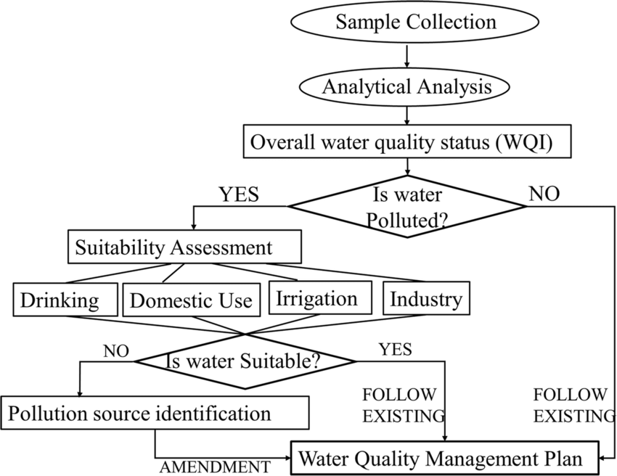

Top of Form

**5. IMPLEMENTATION**

The below table **[Table-1]** is our dataset consisting of 3276 records and 10variables. Here is the glimpse of our raw dataset before any formattin

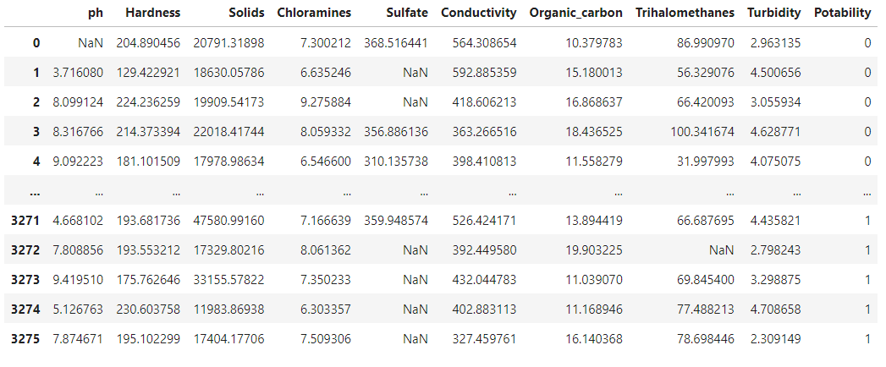

**Table-1: Dataset**

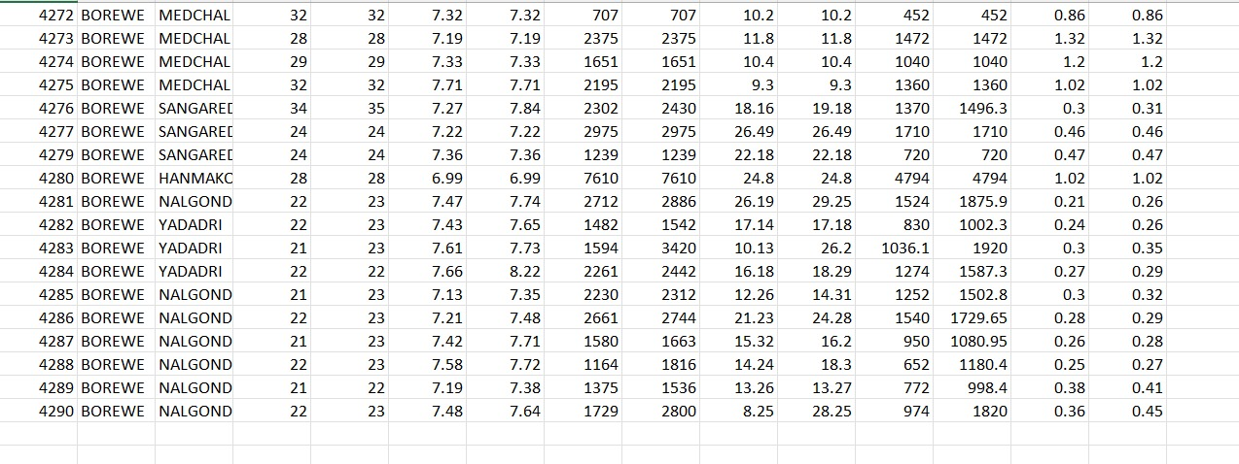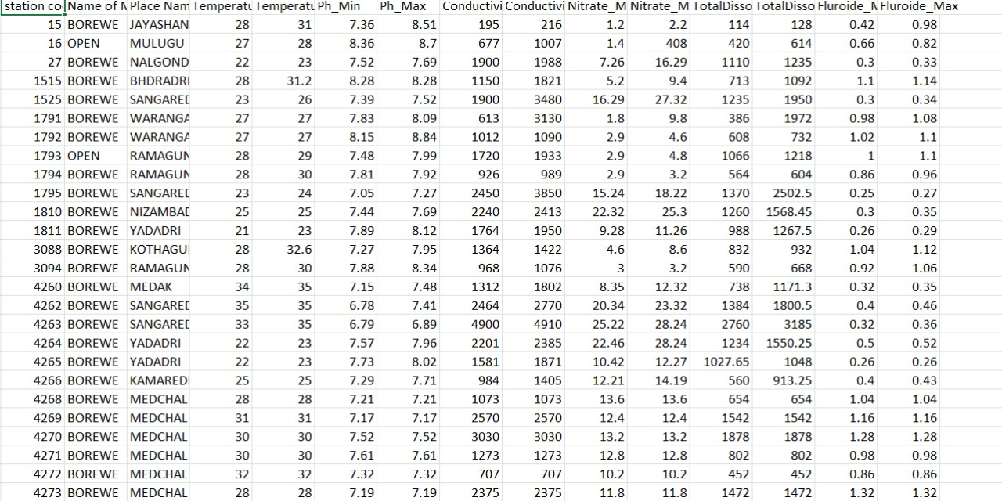

**Table-2: Dataset**

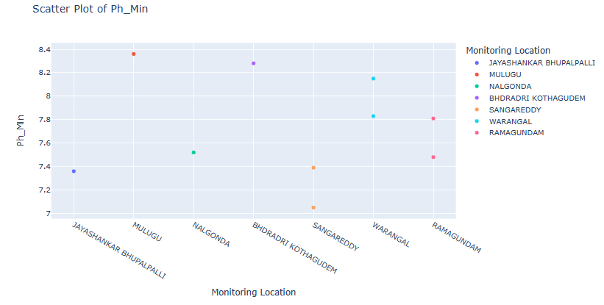

**Fig-1: Minimum PH value of Scatter plot**

We obtained plots on different variables, the Scatter plot **[Fig-1]** here is used for indicating all the Monitoring Location Scatter plot of PH value of Minimum.

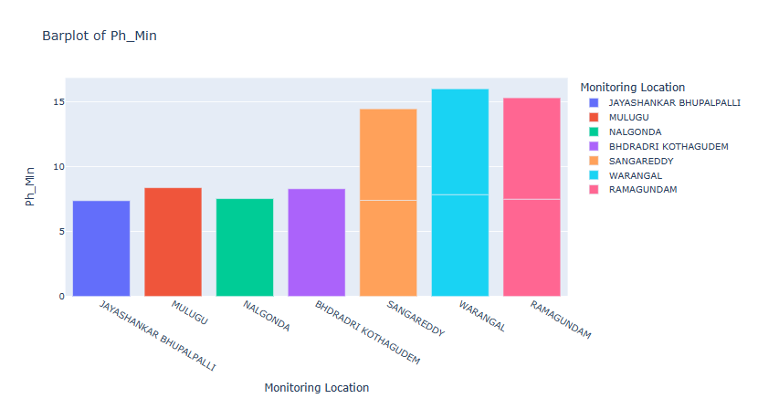

**Fig-2: Minimum PH value of Bar plot**

We obtained plots on different variables, the Scatter plot **[Fig2]** here is used for indicating all the Monitoring Location Bar plot of PH value of Minimum.

**Fig-3: Maximum PH value of Bar plot**

We obtained plots on different variables, the Scatter plot **[Fig3]** here is used for indicating all the Monitoring Location Bar plot of PH value of Maximum.

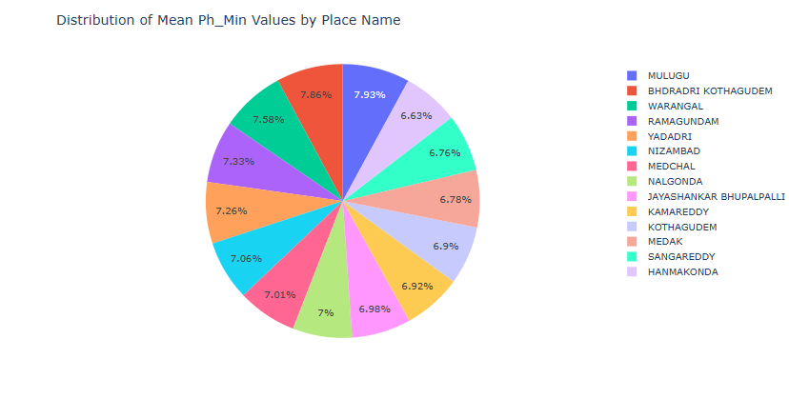

**Fig-4:** **Distribution of** **Mean PH** **Minimum value Place**

The above pie chart **[Fig-4]** shows the observations of all the place Mean PH Minimum value.

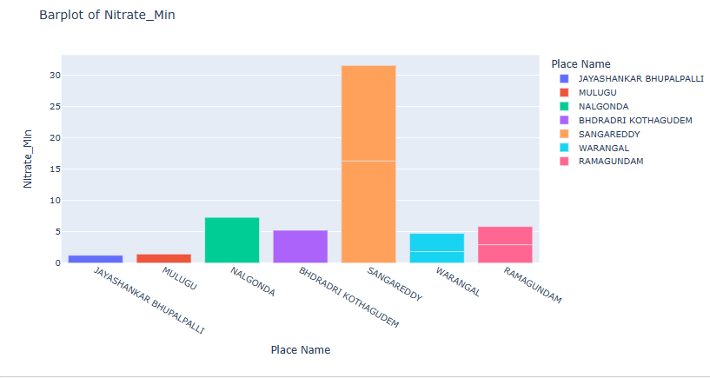

**Fig-5: Nitrate Minimum value Place**

We obtained plots on different variables, the Bar plot **[Fig5]** here is used for indicating all the places Nitrate value of Minimum.

**Fig-6: Nitrate Maximum value Place**

We obtained plots on different variables, the Bar plot **[Fig6]** here is used for indicating all the places Nitrate value of Maximum.

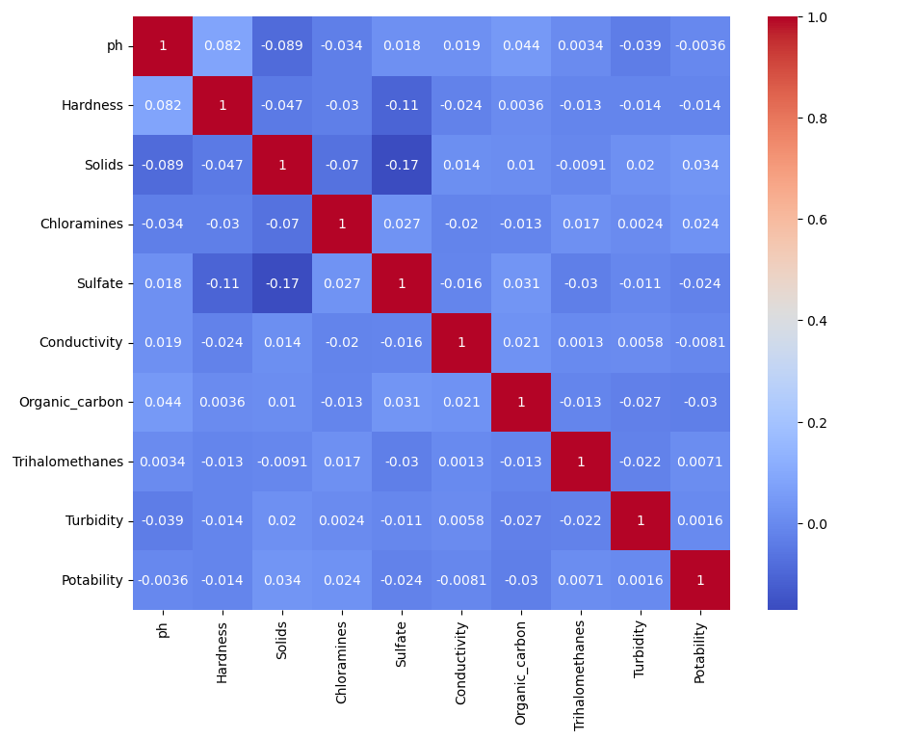

**Fig-7: Correlation matrix of all places**

The colours represent the strength and direction of the correlation **[Fig7]**. The scale on the right side of the image shows that red tones indicate a positive correlation and blue tones indicate a negative correlation. The intensity of the colour corresponds to the strength of the correlation.

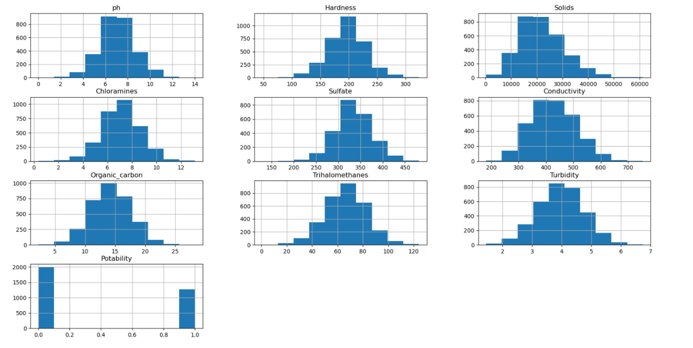

**Fig-8: Histograms of overall variables**

The above histogram **[Fig-8]** shows the observations frequencies of all the attributes.

**6. CONCLUSION**

In Conclusion, the machine learning models are getting more accurate in predicting cardio vascular diseases which can be said to be the most prominent problems in the society. As the work in the field of machine learning is being done, there soon may be new and efficient ways to improve the prediction of heart disease. The machine learning algorithm in our project has used all available attributes well and performed better. The conclusion can be drawn that data analytics and machine learning can be able to predict the chances of a person going to get heart disease by correlating their habits.

**REFERENCES**

[1] Kaur, B., & Singh, W. (2014). Review on heart disease prediction system using data mining techniques. International journal on recent and innovation trends in computing and communication, 2(10), 3003-3008

[2] Ramalingam, V. V., Dandapath, A., & Raja, M. K. (2018). Heart disease prediction using machine learning techniques: a survey. International Journal of Engineering & Technology, 7(2.8), 684- 687.

[3] Jason Brownlee. XGBoost with python.

[4] Fabian Nelli. Python Data Analytics.

[5] Coursera